Instructions for pulsed bias stress

Note: these instructions are also found within PulsedstressV_inputs.vi, which must be used before running pulsed bias stress.

How to do pulsed stress following the method of Salleo et al, APL 86 263505 (2005):

(1) Due to our SPA configuration, only limited ranges are available for pulse period, pulse width, and total stress time. Input your desired parameters into *PulsedstressV_inputs.vi*, adjust them to eliminate any errors, and then note the output values on the right hand side. Note that you can obtain a longer total stress time by concatenating identical pulsed stress commands. For example, if the maximum stress time available using *PulsedstressV_inputs.vi* is 200s, but you want 2000s of stress, then you should repeat the bias stress ten times in a row. Be aware that there will be a short (<5s) delay between two adjacent pulsed bias stress commands.

(2) Write a script file to be run in "text control.vi". The first line should be the stress. For DC voltage stress, use

**sample Vg Vd NumSamples Time(s) SampleInterval(s)**

where SampleInterval(s) is usually 0.004, NumSamples is high (typically 3000, but must be less than Time/SampleInterval), and the length of the bias stress time is Time(s). Note that NumSamples and SampleInterval(s) do not affect the bias stress itself - they only change the recording of data.

For pulsed bias stress, use

**pulsedstressV [s|d] VEstop VgON VgOFF Period(s) PulseONwidth(s) Vd**

where s/d, VEstop, Period(s) and PulseONwidth(s) are all given by the outputs of PulsedstressV_inputs.vi program.

For the recovery section, if you want the currents to be measured using pulsed gate voltages (highly recommended), then issue (once) the command

**pulsed on PulsePeriod(sec) PulsedGateOFFVoltage PulseONWidth(sec)**

If a short DC bias is acceptable, then set the integration time as desired on the screen - no further command is needed.

Also add the general commands

**itime s**

**gaterangemode l [The last character is a lowercase “L”]**

**drainrangmode l [“]**

Then to make the recovery measurements, add the following set of commands, repeated as many times as needed (inserting the desired voltage values for “VG” and “VD”):

wait 7500

transfer s VG VG 0 VD VD 0

wait 7500

transfer s VG VG 0 VD VD 0

wait 7500

transfer s VG VG 0 VD VD 0 ...

The time in the wait statement is in milliseconds, and should be approx. 2500 ms less than the desired spacing between recovery current measurements (here 10 sec). Note that this uses a transfer "sweep" at a single VGS, VDS bias point to measure the recovery current. Repeat these two lines as many times as you like (can be thousands!) to measure the recovery over long periods.

(3) **Before running, in the Panels Controls 2 box, set the Text/Graph to "text" (so that the green light is OFF). This must be done or the recovery measurements will not work.** Also set D/G compliance to 0.01 A, integration to short and D/G/S range to Limited 10uA (These last two settings will affect the time it takes to make each non-pulsed recovery measurement, which generally you want to be as short as possible.)

Because of the complexity, I recommend doing an abbreviated trial run on a test TFT before trying your precious devices!

(4) It’s likely you will generate many, many recovery files (possibly thousands!). Do not try to analyze these by hand! Instead, **use the matlab program *“stress.m”*** on the desktop in room M233 to very quickly extract the recovery data and save it in as a MS Excel file.

Sample pulsed bias script.txt

# The inputs to PulsedStressV_inputs were

# Desired period = 0.5 s

# Desired Pulsed ON width = 0.1 s

# Desired Stress time = 1000 s

# This gives the following output values

# SPA Period (s) = 0.5

# SPA pulse width (s) = 0.0827

# SPA VE_stop = 5.0

# SPA single/double = d

# These values were incorporated along with the desired VG and VD values

# (VGS=20V ON, 0V OFF; VDS=5V) into the "pulsedstressV..." command

#

# The command “pulsed on 0.5 0 0.0827” sets the pulse period, pulse ON width,

# and VGOFF for the recovery measurements – set them to match the

# pulsedstressV command. If you want the recovery measurements to be made in

# continuous mode (not recommended), then instead use the command “pulsed off”

#

# The recovery current was measured every ~10s, so the wait time is

# 1000x(10-2.5)ms=7500

# The VGS=20V and VDS=5V for recovery are the same as for stress

# I repeated the recovery commands many, many times in the script, and then, when

# I wanted to terminate the measured I just "stopped" the labview program using the

# button in the TOP TOOLBAR LINE. Note: don't use the STOP button in the middle of

# the page - which only stops the current script command, but continues to execute

# the remaining script.

#

#

pulsedstressV d 5 20 0 0.5 0.0827 5

pulsed on 0.5 0 0.0827

itime s

gaterangemode l

drainrangemode l

wait 7500

transfer s 20 20 0 5 5 0

wait 7500

transfer s 20 20 0 5 5 0

wait 7500

transfer s 20 20 0 5 5 0

wait 7500

transfer s 20 20 0 5 5 0

wait 7500

transfer s 20 20 0 5 5 0

wait 7500

transfer s 20 20 0 5 5 0

wait 7500

transfer s 20 20 0 5 5 0

wait 7500

transfer s 20 20 0 5 5 0

wait 7500

transfer s 20 20 0 5 5 0

wait 7500

transfer s 20 20 0 5 5 0

wait 7500

transfer s 20 20 0 5 5 0

wait 7500

transfer s 20 20 0 5 5 0

wait 7500

transfer s 20 20 0 5 5 0

wait 7500

transfer s 20 20 0 5 5 0

wait 7500

transfer s 20 20 0 5 5 0

wait 7500

transfer s 20 20 0 5 5 0

PulsedstressV_inputs.vi

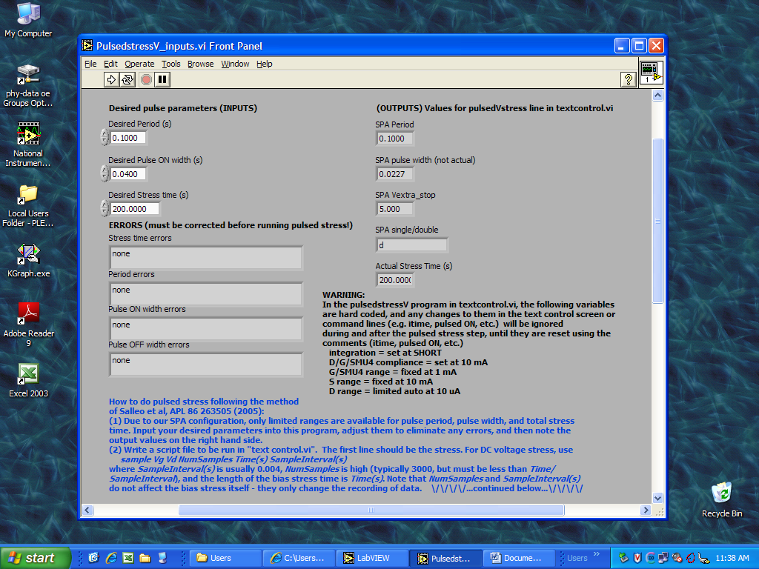

Text control.vi settings and sample script in place

